Food Idioms
  the apple of my eye  = my favourite person |   a bad egg  = a bad person | 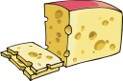  a big cheese  = an important person
  as cool as a cucumber  = very calm |   a couch potato  = a very lazy person | 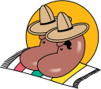  full of beans  = full of energy
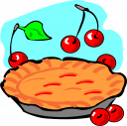  a finger in every pie  = to be involved in everything |   my cup of tea  = what I like |   cry over spilt milk  = to be sorry about something which can’t be undone
  a smart cookie  = a clever person | 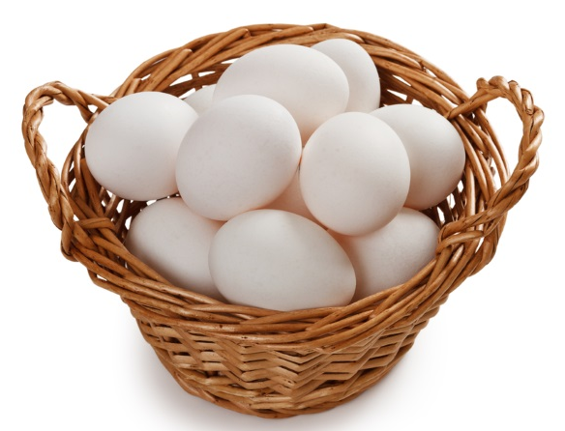  don’t put your eggs all in one basket  = don’t risk everything in one venture | 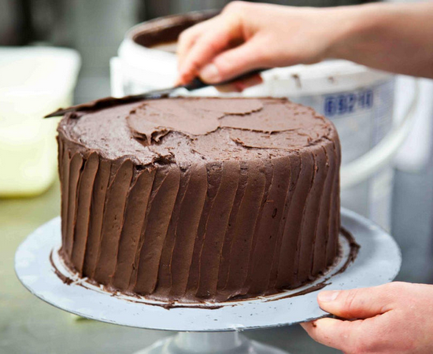  the icing on the cake  = an extra thing to make something special

Music suggestion: https://www.youtube.com/watch?v=ZgBbZBcj5wQ
Exercise. Complete the following using the idioms on page 1.
1. He is always ________________________ - he never worries about anything!
2. My uncle is on the board of five companies. He has ________________________.
3. My son knows how to fix any problem on my computer. He’s a real ____________________.
4. I’m sorry, jazz music isn’t ________________________. I prefer rock and roll.
5. My daughter is so special to me - she is the ________________________.
6. If I were you, I would invest in more than one company. You shouldn’t __________________.
7. If I were you, I would stay away from him! He is a ________________________.
8. Stop being miserable! Don’t ________________________! It was only a cheap vase.
9. Maria is really ________________________ tonight. She doesn’t stop chatting and singing.
10. Wow! Not only did you get promoted, but you also got your own office on the top floor! That really is the ________________________!
11. My dad is the CFO. He is a ________________________ in the company!
12. My son just sits on the sofa watching TV all day. He really is a ________________________.

